S126 HIT137 SOFTWARE NOW Assignment 02
Group - 24
Sabin Man Singh Pradhan -s401417 Nishant Shrestha- s400342. Karan Pandey- s403497. Sabrabham Shrestha -s404389

Table of Contents
Question 1: Encryption & Decryption 2
Code: 2
Output for question 1: 5
Raw text: 5
Encrypted file : 5
Decrypted file : 6

Question 2: 6
Output : 11
Sample input file 11

Question 1: Encryption & Decryption
Descprition :
This program reads text from a file and applies custom encryption using different shifting rules for letter groups (a–m, n–z, A–M, N–Z) based on shift1 and shift2. It then decrypts the text by reversing the process and verifies that the decrypted output matches the original file

Code:
# Function to shift a character inside its own group
# This function keeps characters within a specific range (e.g., a-m or n-z)
# and applies circular shifting using modulo arithmetic.
def shift_within_group(char, group_start, group_size, shift, forward=True):
# find the position of the character inside the group
offset = ord(char) - ord(group_start)

# move forward or backward inside the group using modulo for wrap-around
if forward:
new_offset = (offset + shift) % group_size
else:
new_offset = (offset - shift) % group_size

# convert back to a character
return chr(ord(group_start) + new_offset)

# Function to encrypt one character based on assignment rules
# Each group (a-m, n-z, A-M, N-Z) uses a different transformation rule
def encrypt_char(char, shift1, shift2):

# lowercase a-m → shift forward by shift1 * shift2
if 'a' <= char <= 'm':
return shift_within_group(char, 'a', 13, shift1 * shift2, forward=True)

# lowercase n-z → shift backward by shift1 + shift2
elif 'n' <= char <= 'z':
return shift_within_group(char, 'n', 13, shift1 + shift2, forward=False)

# uppercase A-M → shift backward by shift1
elif 'A' <= char <= 'M':
return shift_within_group(char, 'A', 13, shift1, forward=False)

# uppercase N-Z → shift forward by shift2 squared
elif 'N' <= char <= 'Z':
return shift_within_group(char, 'N', 13, shift2 * shift2, forward=True)

# non-alphabet characters remain unchanged
return char

# Function to decrypt one character
# Decryption reverses the exact transformation applied during encryption
def decrypt_char(char, shift1, shift2):

# lowercase a-m → reverse of forward shift → shift backward
if 'a' <= char <= 'm':
return shift_within_group(char, 'a', 13, shift1 * shift2, forward=False)

# lowercase n-z → reverse of backward shift → shift forward
elif 'n' <= char <= 'z':
return shift_within_group(char, 'n', 13, shift1 + shift2, forward=True)

# uppercase A-M → reverse of backward shift → shift forward
elif 'A' <= char <= 'M':
return shift_within_group(char, 'A', 13, shift1, forward=True)

# uppercase N-Z → reverse of forward shift → shift backward
elif 'N' <= char <= 'Z':
return shift_within_group(char, 'N', 13, shift2 * shift2, forward=False)

# non-alphabet characters remain unchanged
return char

# Function to process the whole text
# Applies encryption or decryption character by character
def transform_text(text, shift1, shift2, encrypt=True):
result = ""

# iterate through each character in the text
for char in text:
if encrypt:
result += encrypt_char(char, shift1, shift2)
else:
result += decrypt_char(char, shift1, shift2)

return result

# Function to encrypt the file
# Reads raw_text.txt and writes encrypted result to encrypted_text.txt
def encrypt_file(shift1, shift2):
with open("raw_text.txt", "r", encoding="utf-8") as file:
original_text = file.read()

encrypted_text = transform_text(original_text, shift1, shift2, encrypt=True)

with open("encrypted_text.txt", "w", encoding="utf-8") as file:
file.write(encrypted_text)

# Function to decrypt the file
# Reads encrypted_text.txt and writes decrypted result to decrypted_text.txt
def decrypt_file(shift1, shift2):
with open("encrypted_text.txt", "r", encoding="utf-8") as file:
encrypted_text = file.read()

decrypted_text = transform_text(encrypted_text, shift1, shift2, encrypt=False)

with open("decrypted_text.txt", "w", encoding="utf-8") as file:
file.write(decrypted_text)

# Function to verify the result
# Compares original and decrypted text to ensure correctness
def verify_decryption():
with open("raw_text.txt", "r", encoding="utf-8") as file:
original_text = file.read()

with open("decrypted_text.txt", "r", encoding="utf-8") as file:
decrypted_text = file.read()

if original_text == decrypted_text:
print("Verification successful: decrypted text matches original text.")
else:
print("Verification failed: decrypted text does not match original text.")

# Main function
# Takes user input for shift values and runs the full process
def main():
shift1 = int(input("Enter shift1: "))
shift2 = int(input("Enter shift2: "))

encrypt_file(shift1, shift2)
decrypt_file(shift1, shift2)
verify_decryption()

# Program entry point
if __name__ == "__main__":
main()

Output for question 1:

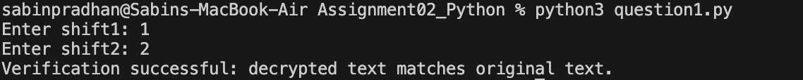

Raw text file:
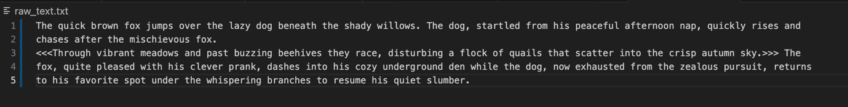

Encrypted file :
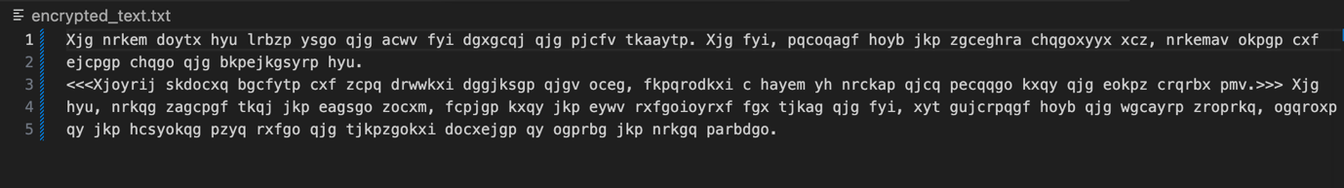

Decrypted file :

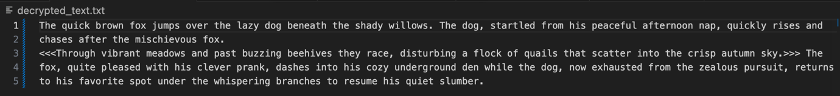

Question 2:
This program processes input data from a file, performs the required operations based on the given problem, and generates the correct output. It ensures proper handling of input, applies the logic step by step, and displays or stores the result as specified.

Code
# Question 2: Expression Evaluator

# ---------------- TOKEN CLASS ----------------
class Token:
def __init__(self, type_, value):
self.type = type_
self.value = value

def __str__(self):
return f"[{self.type}:{self.value}]"

# ---------------- NODE CLASS ----------------
class Node:
def __init__(self, value, left=None, right=None):
self.value = value
self.left = left
self.right = right

# ---------------- TOKENIZER ----------------
def tokenize(expression):
tokens = []
i = 0

while i < len(expression):
ch = expression[i]

if ch.isspace():
i += 1
continue

if ch.isdigit():
num = ch
i += 1
while i < len(expression) and expression[i].isdigit():
num += expression[i]
i += 1
tokens.append(Token("NUM", num))
continue

if ch in "+-*/":
tokens.append(Token("OP", ch))
i += 1
continue

if ch == "(":
tokens.append(Token("LPAREN", ch))
i += 1
continue

if ch == ")":
tokens.append(Token("RPAREN", ch))
i += 1
continue

raise ValueError("Invalid character")

tokens.append(Token("END", ""))
return tokens

# ---------------- PARSER ----------------
class Parser:
def __init__(self, tokens):
self.tokens = tokens
self.pos = 0

def current(self):
return self.tokens[self.pos]

def eat(self, type_=None, value=None):
token = self.current()

if type_ and token.type != type_:
raise ValueError("Unexpected token")
if value and token.value != value:
raise ValueError("Unexpected token")

self.pos += 1
return token

# expression → term ((+|-) term)*
def parse_expression(self):
node = self.parse_term()

while self.current().type == "OP" and self.current().value in "+-":
op = self.eat("OP").value
right = self.parse_term()
node = Node(op, node, right)

return node

# term → unary ((*|/) unary)*
def parse_term(self):
node = self.parse_unary()

while self.current().type == "OP" and self.current().value in "*/":
op = self.eat("OP").value
right = self.parse_unary()
node = Node(op, node, right)

return node

# unary → - unary | primary
def parse_unary(self):
if self.current().type == "OP" and self.current().value == "-":
self.eat("OP", "-")
return Node("neg", self.parse_unary())

return self.parse_primary()

# primary → NUM | (expression)
def parse_primary(self):
token = self.current()

if token.type == "NUM":
self.eat("NUM")
return Node(token.value)

if token.type == "LPAREN":
self.eat("LPAREN")
node = self.parse_expression()

if self.current().type != "RPAREN":
raise ValueError("Missing )")

self.eat("RPAREN")
return node

raise ValueError("Invalid expression")

def parse(self):
node = self.parse_expression()

if self.current().type != "END":
raise ValueError("Extra tokens")

return node

# ---------------- TREE TO STRING ----------------
def tree_to_string(node):
if node.left is None and node.right is None:
return str(node.value)

if node.value == "neg":
return f"(neg {tree_to_string(node.left)})"

return f"({node.value} {tree_to_string(node.left)} {tree_to_string(node.right)})"

# ---------------- EVALUATOR ----------------
def evaluate(node):
if node.left is None and node.right is None:
return int(node.value)

if node.value == "neg":
return -evaluate(node.left)

left = evaluate(node.left)
right = evaluate(node.right)

if node.value == "+":
return left + right
if node.value == "-":
return left - right
if node.value == "*":
return left * right
if node.value == "/":
if right == 0:
raise ZeroDivisionError()
return left // right

raise ValueError("Unknown operator")

# ---------------- PROCESS ----------------
def process(expr):
expr = expr.strip()

try:
tokens = tokenize(expr)
parser = Parser(tokens)
tree = parser.parse()
result = evaluate(tree)

token_str = " ".join(str(t) for t in tokens)

return [
f"Input: {expr}",
f"Tree: {tree_to_string(tree)}",
f"Tokens: {token_str}",
f"Result: {result}"
]

except:
return [
f"Input: {expr}",
"Tree: ERROR",
"Tokens: ERROR",
"Result: ERROR"
]

# ---------------- MAIN ----------------
def main():
with open("sample_input.txt") as f:
lines = f.readlines()

output = []

for line in lines:
if line.strip():
output.extend(process(line))
output.append("")

with open("sample_output.txt", "w") as f:
f.write("\n".join(output).rstrip())

if __name__ == "__main__":
main()

Output :
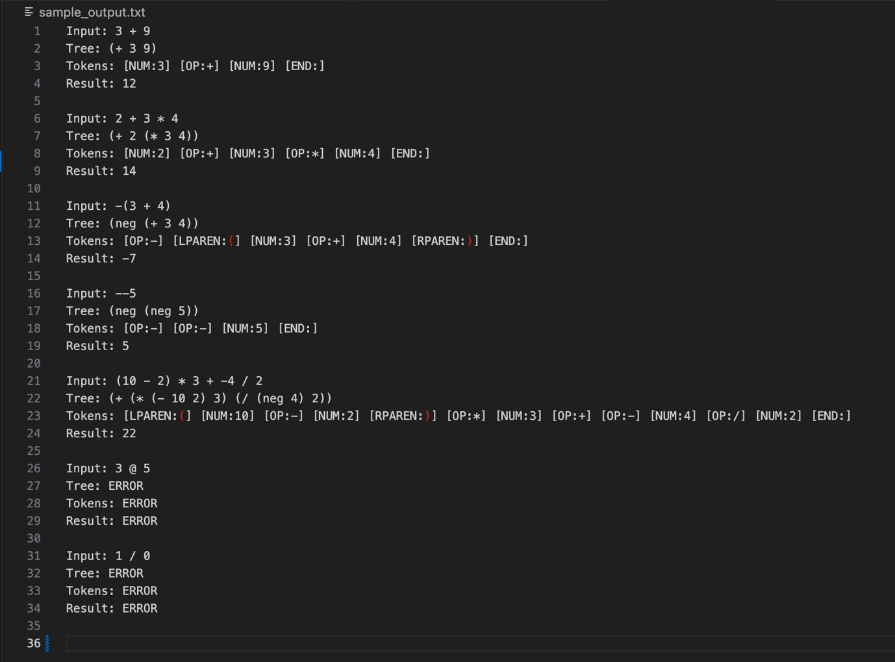

Sample input file
